**Yacob Reyneke Project Brief — “Demons & Dragons” Game**

Prepared by Karim Zouak – 28.02.22

*Description*

A third-person game built in Unreal Engine to demonstrate Yacob’s capacity for game development. It will feature AI-driven characters, hand-to-hand combat and puzzles. This will feel like a short but complete game.

*Tone & Aesthetic*

Light-hearted, humorous. Draws on classic third-person gaming tradition but without taking itself so seriously and falling into the regular rhythms/clichés. An important central theme is that things are not always what they seem. The visual style will be fantasy/photo realistic.

*Timeline*

To be completed in April (not a hard deadline).

*Characters*

1. Little Boy (Protagonist) – the player character is an ordinary little boy who lives in the woods.
2. Demon Princess (Antagonist) – the main villain is a fiery, powerful demon who has stolen the hero’s dragon
3. Baby Dragons – there are two baby dragons with a subtle difference between the two. (This will depend on the asset options. Maybe the location of spots, or the colour of the eyes, are slightly different?)
4. Foot soldiers – the castle has many AI-driven foot soldiers that the hero can either avoid or fight

*Sets*

Primary set is a castle exterior and interior. A castle is built into a cliff face at the edge of a forest. There is a moat around it, with a drawbridge that descends from the other side. On one side, the moat goes into a cave that is obscured by a bush.

Inside the castle are several hallways, a storage room and the Demon Princess’ throne room, where the dragon is in a small hanging cage.

Secondary set (for an intro cut scene) is a log cabin exterior and interior. It is in a clearing in a forest. The hero is asleep in bed with his dragon asleep at his feet, lit by a dying fire.

*Intro Cut Scene:*

The Demon Princess is walking through the forest making a funny calling noise, trying to find something, when she comes across a log cabin. In the window, she sees the Little Boy asleep in bed with a little dragon curled up at his feet. It has a gentle string attached round its neck and loosely tied to a bed post. The Demon Princess has found what she’s looking for! The Demon Princess puffs into smoke and enters the room. She grabs the baby dragon by the throat and lifts it into the air. A satisfied smile crosses her lips.

The Little Boy wakes up with a stretch as the morning light pours through the window. He looks down at the foot of the bed and sees the string has been cut! He screams and jumps out of bed, tearing out the door and through the forest.

*Gameplay — Puzzles and Solutions*

1. Enter the castle:

The player finds himself at the edge of the forest near a clearing in front of the castle. Two guards patrol back and forth. There is a bridge across the moat and a locked gate to get into the castle. Whenever she approaches the bridge, the guards notice and approach, no matter how far off they are. He could wait for them to be furthest and make a run for it, but will discover that the gate has a large lock on it. How can he get into the door?

* 1. He can fight the guards to get the key. When he fights the first guard (either one) the second go back on patrol until they are finished. The first one will be very embarrassed and defensive that he forgot his key at home. He will have to defeat the second guard, too, who admits that he dropped his key in the moat. The player will need to try the gate to discover that it is open – if they have lost the keys then how would they lock it, right? Inside the gate you enter the interior of the castle, where hallways lead to staircases and rooms.
  2. One side of the moat goes into the cliff side, but is obscured a bit by a bush. Behind the bush we can discover a cave, where the water is very shallow and the player can walk in. There is a lever with a sign next to it that says “emergency access, do not use under any circumstances”. Pulling the lever will open a secret door, giving access into the main castle.

1. Get into the throne room:

The player will need to go through a maze of hallways to find the throne room, avoiding patrolling guards. The challenge is to figure out the correct pathway to the throne room. How to do it? (The actual solution will depend on the level design).

* 1. Each guard you defeat will give you a correct instruction (eg. go down the hall, go up the stairs, go in the 3rd door on the right). You will have to defeat a varying number of guards depending on how close you are. They will eventually lead you to a door with a sign that says “throne room”.
  2. All of the doors in the hallways are locked, except for one with a sign that says “storage room”. Inside is a storage closet, which has extra signs, one of which says “throne room’. There are also healing potions, which you can drink, but the Little Boy won’t carry any with him as he thinks that is greedy. If you change the “storage room” with the “throne room” sign, then when you open the door it will reveal the throne room.

1. Defeat the Demon Princess:

In the throne room is the Demon Princess, sitting upon her throne with the baby dragon in a cage hanging from the ceiling. There is an endlessly deep fire pit in the middle of the room. The player can choose to sneak behind objects around the room -- avoiding her gaze to avoid detection -- to attack from close, or talk to her at any point. How to get the dragon back?

* 1. If the player attacks the Demon Princess, they will need to avoid special attacks. Dying here is the end of the game, leading to a respawn at the start. The Demon Princess can not be defeated by damage because she always moves out of the way, so the player needs to position her to move into the well, where she falls to her death.
  2. They can talk it out, where the correct path of conversation reveals that the Demon Princess believes that she just took her missing dragon back – she is mortified that she stole it. She is, after all, a Demon. And a Princess. NOT a scumbag devil. The second baby dragon will fly in through the window to confirm it, and everybody laughs in relief as the credits roll.

*Notes on Combat*

The combat will be a bit silly and less threatening than a regular game of this type. The guards will hit the boy and knock him over. When he’s down, they’ll shout at him to go away. When his health is depleted, he will respond “God!” and stomp back to the edge of the forest, effectively resetting the game. His attacks are tiny punches at their knees. After enough damage, the guards will fall to the floor and rub their shins complaining that it really hurts.

Layouts

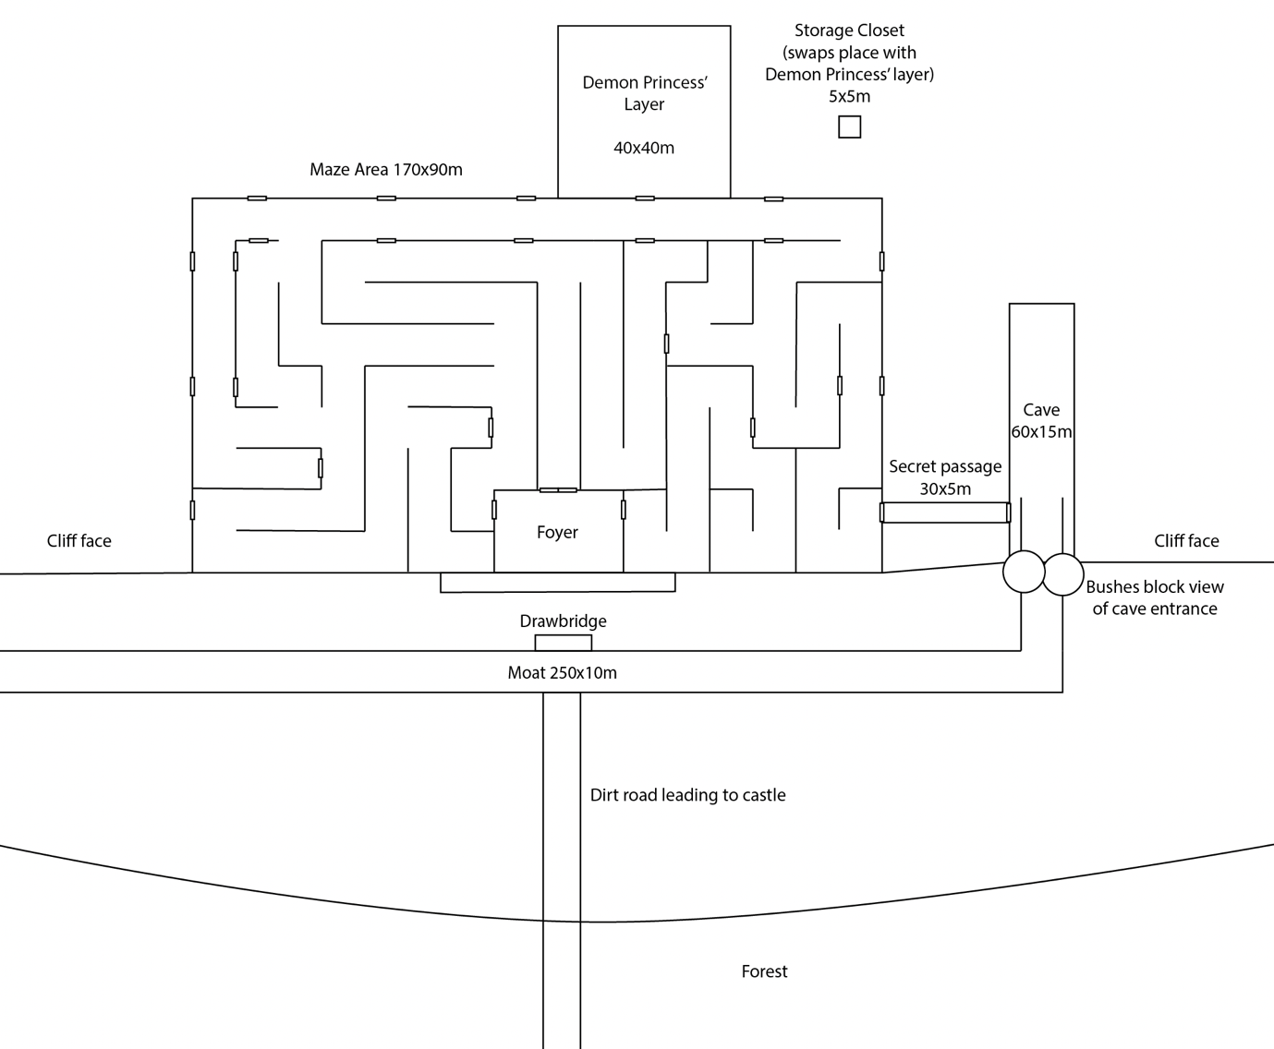

Main level

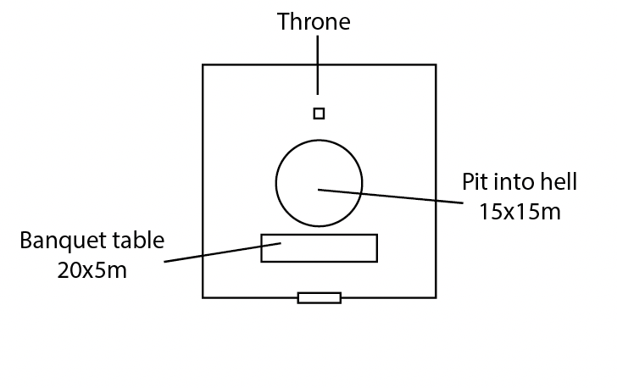

Demon Princess’ throne room detail

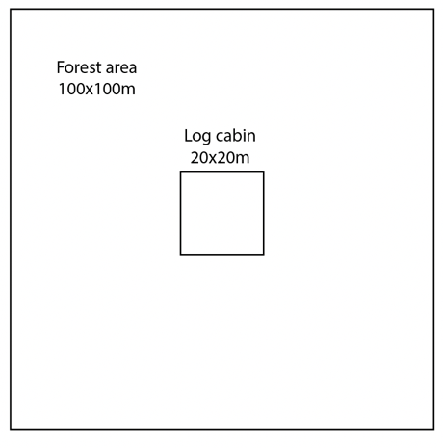

Cut scene to start game — log cabin in forest

Image References

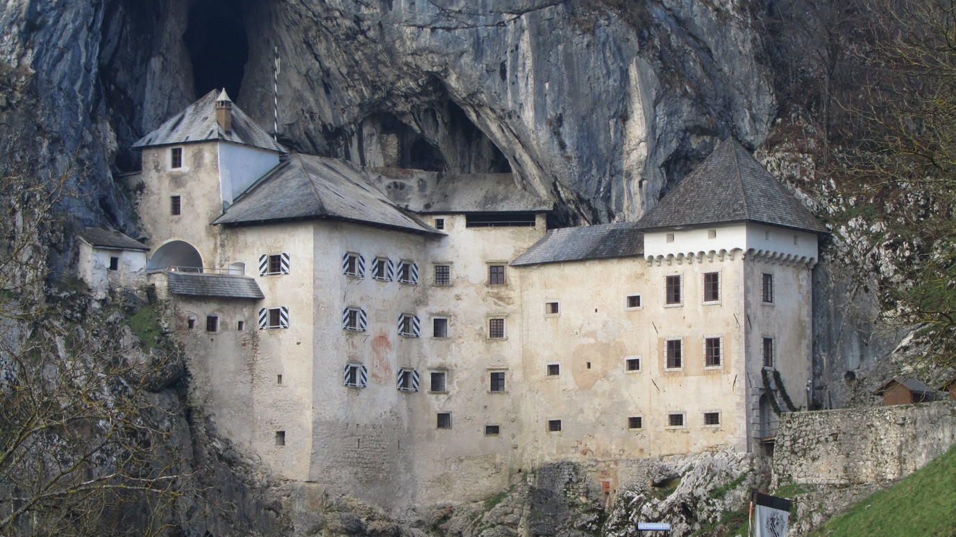

The castle is built into a cliff face



A clearing in the forest where the log cabin is found

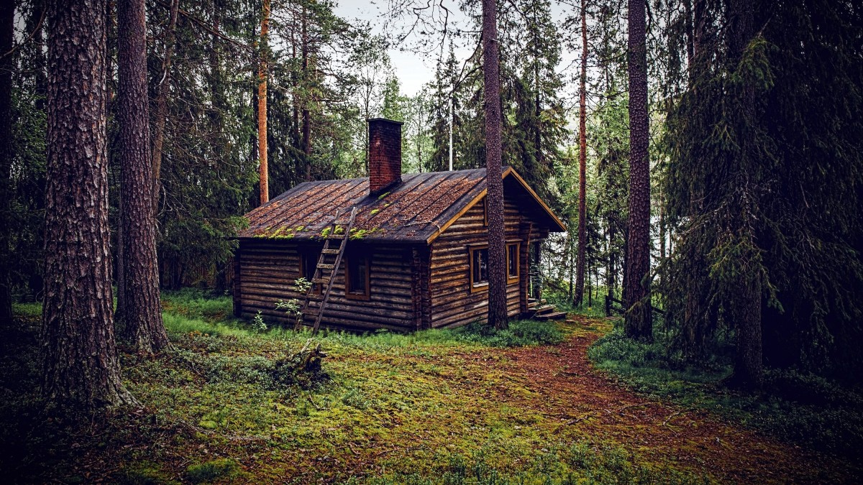

A simple log cabin

*End of document.*